Annotation requirement

# Files illustration

* The main data folder named “OH0037_2023_05_10_15_17_17” contains the subject and recorded date information. The annotation should be performed in each data folder separately.
* All the video data are in the ‘videos’ subfolder, it includes 9 videos from static cameras (*output*.mp4) and 1 video from the egocentric camera (hololens.mp4)
* The annotations should be stored in the ‘label’ subfolder, all the annotations for one session data can be saved in one file.
* The following are the examples of all the ten camera views.



# Action list

| Verbs | | Nouns | | | | | |  |
| --- | --- | --- | --- | --- | --- | --- | --- | --- |
| Action | | **Food** | | | **Objects** | | **Appliances** | **Recipes** |
| Open | Taste | Stock cube | Radish | Peanuts | Pan | Colander | Fridge | Omelet |
| Close | Tap | Frying Oil | Avocado | Broth | Pot | Fork | Cupboard | Ratatouille |
| Cut | Add | Fresh thyme | Processed ingredients | Tamarind paste | Doser Glass | Cutting board | Ventilation | Pad Thai |
| Wash | Hold | Zucchini | Onions | Shrimps | Spatula | Plate | Sink | Risotto |
| Clean | Move | Eggplant | Shallots | Water | Bowl | Pot lid | Stoves | Tomato salad |
| Switch | Sauté | Mushrooms | Tofu | Salt | Knife | Bottle | Drawer | Green salad |
| Stir | Dry | Bell pepper | Pasta | Salad | Grate | Soap | Trash bin |  |
| Wait | Pick | Bean sprouts | Noodles | Lemon | Trash | Sponge |  |  |
| Put | Read | Sauce | Rice | Tomatoes | Towel | Peeler |  |  |
| Split | Press | Cucumber | Butter | Eggs | Package | Button |  |  |
| Touch | Slide | Seasoning | Carrots |  | Whip | Salt box |  |  |
| Peel | Shake |  |  |  | Spoon | Recipe |  |  |
| Pour | Squat |  |  |  | Hand | Salad bowl |  |  |
| Throw | Carry |  |  |  | Tissue |  |  |  |

# Annotation rules

Some rules for annotation using a limited set of words.

* Actions can be annotated in a simultaneous manner
* Food are defined by their specific names only if only they are targeted by the action.
* When food is processed but not yet cooked please use *Processed ingredients*. By definition, this does not apply to *Salads*.
* If all ingredients are added to the mix and the participant manipulates the mix, please use the name of the corresponding recipe instead.
* An object should be defined as *Trash* as late as possible before going to the *Trash bin*. The object should keep its name (if known) as long as possible, the last action should still include *Trash* in its name. (example *Pick Zucchini, Put Trash*)
* Please be precise as possible on the object interaction, for instance the participant will never hold a *seasoning* but a *bottle*, however he may *add* the *seasoning*.

**Action description**

* **Open/Close:** Opening/Closing objects such as *Pot, Package, Butter, Tamarind paste, Water, Oil, Sauce,* or appliances such as *Fridge, Cupboard, Drawer*
* **Cut:** Operation of *Cut* an object or food when holding a knife. Exception: The action of opening a package with a knife should be defined as *open*.
* **Wash:** Washing an object or food requires the use of a certain amount of water and soap and should happen in the sink area. To be contrasted with *clean* which is reserved for areas apart from the sink.
* **Clean:** Cleaning an object/food requires the use of a *Tissue, Towel, sponge,* or *hand.* It can happen in any area apart from the sink area. It could involve motions such as wiping, or removing food from the knife in a *cut* action.
* **Stir :** Motion of stirring which can happen either in *Salad Bowls*, *Pan, Pot*
* **Wait :** This action is not related to any noun
* **Put:** Action of setting down an object. When followed by *Pick* and *Hold* it should have a maximum duration of 30 frames and must end whenever the hand loses contact with the object.
* **Split:** Action of separating processed ingredients in two parts. To be contrasted with *Cut* which mostly happen with a knife. *Cut* must be prioritized over *split* if hesitation.
* **Touch:** The action of barely touching an object and has absolutely no consequences, can be involuntary. To be contrasted with *Tap* (repetitive movement) and *Press* (voluntary and has a certain degree of consequences).
* **Peel:** Removing the skin of a specific food. Can happen with a *Peeler*, a *Knife* or directly with *hands.*
* **Pour:** The action of setting down a liquid (*Water, Oil, Sauce,Broth)*  into a recipient.
* **Sauté:** Sautéing represents the movement where the cook shakes the pan instead of *Stir*.
* **Taste:** The action of taking food in the mouth. The action should be annotated from the moment the food reaches the mouth of the participant and should be following *Pick* and *Hold.*
* **Tap:** Tap with the *Spatula*, *Spoon,* or *Knife* to remove the stuck residues.
* **Add:** Add a set of ingredients to another set of ingredients.
* **Throw:** Defined when the object is thrown in the air.
* **Carry:** Defined when the interacting object is lifted. Intermediary action defined in between *Pick* and *Put*.
* **Hold:** Defined when the person try to stabilize the object with almost no placement. *Hold* must be annotated also during *Cut* if the participant *Hold* with the contralateral hand*.*
* **Move:** Move is an action that involves the displacement of an object without lifting them.
* **Dry:** Action happening after *Wash*. Drying requires the use of a *Towel* or *Tissue.* Involve the action of wiping on an object. To be contrasted with *Shake* when performed without *Towel* or *Tissue*.
* **Pick:** Pick an object, must typically be followed by *Hold* and eventually *Put.* *Pick* is defined from the moment when the reaching movement starts and ends at the hand-object contact instant. *Pick* can last for a maximum of 30 frames.
* **Read:** Applies to *Recipe*but also to any object with associated text such as *Package* or *Bottle*.
* **Press:** Typically *Press Button* when the participant calibrates the stoves or *Press Hands* when the participant open/close the HoloLens menu by pressing their wrist. To be contrasted with *Tap (repetitive movement with an object)* and *Touch* (No consequences of the action). *Press Button* can be defined once for repetitive instance of the actions as long as the arm of the participant does not retract but must not intersect with *Slide Button* (For the slide *button* in the middle of the *stoves*)
* **Slide:** Correspond to the sliding of *Hand* or an object on a surface or other object. The participants have the possibility to *Slide* the *Button* of the stoves.
* **Shake:** Move an object from side to side with a forceful, jerky movement. Should be used instead of *Dry* when relevant.
* **Squat:** The *Squat* action is not associated with any noun. Usually happens in front of the fridge.
* **Switch**: Switch object from one hand to another, annotate when both hands are in contact with the object.

**Clarification of special Food/Objects**

* **Tamarind Paste** is only used in the *Pad Thaï* recipe as a paste mixed with water. After dilution please use *Sauce*
* **Broth** is only used in the *Risotto* recipe after the stock cube is added to the water, the participant typically *Add Broth* to the *Rice*
* To avoid confusion, *Frying Oil* should only be used when *Frying* *Oil* is added to the *pan*. Otherwise it is considered a *Sauce*.
* **Sauce** : Any cooking liquid including oils, vinegar, wine and liquid mixes. Adding *seasoning* to a *sauce* does change its nature. Exception: Frying oil
* **Salt:** To avoid confusion, must be only used when adding salt to the pasta water. Otherwise it is considered as *Seasoning.*
* **Pasta** are only present in the *ratatouille* (wheat pasta)
* **Noodles**are used in *Pad Thaï* (rice noodles).
* **Seasoning** involves any herbs, salts or spices added with a shaking motion. Exception : Salt when added to the water of the pasta.
* **Bowl and salad bowl:** The EPFL Smart Kitchen possess 2 salad bowls of different size and metallic. Any other spheric shaped container can be considered as a *Bowl*. It can involve the small yellow bowl and eventually the lunch boxes.

# Annotation illustration

* Our required task is action segmentation. Given the input multi-view videos, the start time, end time, verb and noun should be annotated for each video segment.

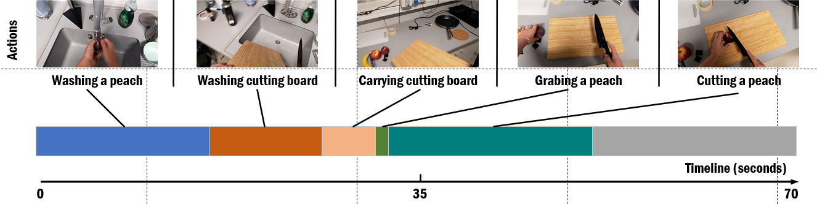

* Note that the action segments can also overlap, e.g., hold knife and cut tomato.
* During the annotation, the annotator should focus on multiple views to make sure the actions are clearly visible. But there is no need to watch all 10 videos.
* We do not have any preference concerning the tool to use to annotate this data. If needed, we can also provide our [annotation tool](https://github.com/amathislab/dlc2action_annotation/blob/main/readme_media/userguide.md), which is able to take multi-view videos as inputs and annotate multiple actions simultaneously.

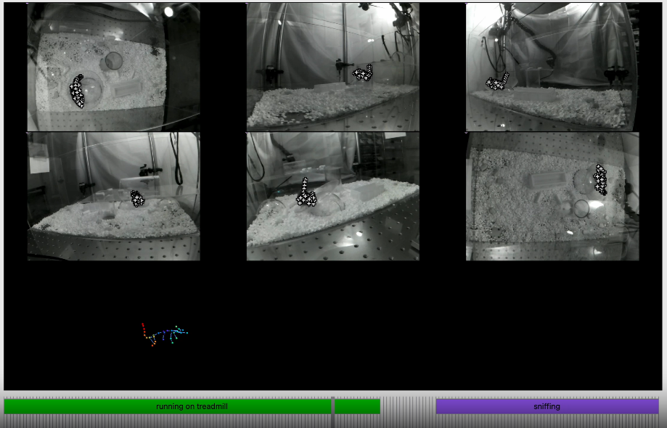

# Output format

The output format that we use is given as a tuple the following structure:

(Information dictionary, vocabulary of actions, individual names, annotation data)

* **Information dictionary (dict):**

| {“datetime” : “%y-%m-%d %t,  “annotator” :[annotator_name],  “video_file” : [video_name.mp4]} |
| --- |

* **Vocabulary of actions (dict):**

| {“Nouns”: [Eggs, Radish,Tomatoes, Avocado, Basil, Carrots, Thyme, Onions, Zucchini, Shallots, Eggplant, Tofu, Mushrooms, Pasta, Bell pepper, Noodles …],  “Verbs”: [Open, Taste,Close, Cook, Cut, Add,Wash, Hold,Clean, Pull, Push,Stir, Dry,Wait, Pick…] |
| --- |

* **Names of individuals** **(list)**:

| [‘OH0037’’] |
| --- |

* **Data (list)**:

The Time segments are numpy arrays (dtype = float64). Each segment is composed of 5 elements [start_frame, end_frame, confusion, verb, noun]. Confusion scales from 0 (absolutely confident that a given action is happening) to 1 (not confident that a given action is happening). There is no order required in the data format.

Here is an example of data format for one individual:

| [[ 0, 3, 0, cut, tomato],  [525, 799, 0, pick, knife],  [ 4, 524, 0, hold, knife],  [ 0, 799, 0, read, recipe],  [179, 183, 0, pick,tomato],  [240, 250, 0, wash, hand],  [396, 407, 0, pick spatula],  [ 1, 8, 0, stir, processed_ingredients],  [ 19, 26, 0, wait, None],  [ 41, 46, 0, press, button],  [ 58, 64, 0, sauté, pad_thai],  [ 1468, 6486, 0, hol_vis, None]] |
| --- |